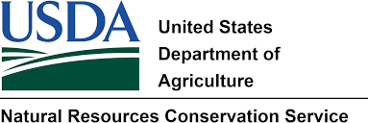

Date

I, , request assistance under the Emergency Watershed Protecting Program (EWPP) and give permission to access my land located in Lincoln County, NM to the Natural Resources Conservation Service and Village of Ruidoso for the purpose of conducting site visits associated with the effects of the Mcbride Fire and windstorm on April 12th, 2022

Landowner
Mailing and Physical Address
City | State | Zip Code
Contact Phone Number |  | Cell Phone Number
Email address

Description of Damage and Threat to Life or Property

